Monday | Tuesday | Wednesday | Thursday | Friday | Saturday | Sunday
 |  |  |  |  | 1 | 2
3 | 4 | 5 | 6 | 7 | 8 | 9
Early Dismissal

End of the Year BBQ

10 | 11 | 12 | 13 | 14 | 15 | 16
 |  |  | 8th Grade Graduation | School Mass
17 | 18 | 19 | 20 | 21 | 22 | 23
Early Dismissal  **Last Day Pre-K For All | Early Dismissal | Early Dismissal | Early Dismissal  Last Day of School!
24 | 25 | 26 | 27 | 28 | 29 | 30


Note: The School calendar includes built in days for inclement weather or emergency school closings. In the even event our school does not use these days, the school calendar may end as early as June 14th. Final decisions about the last day of school will be made by May 30th 2019.
June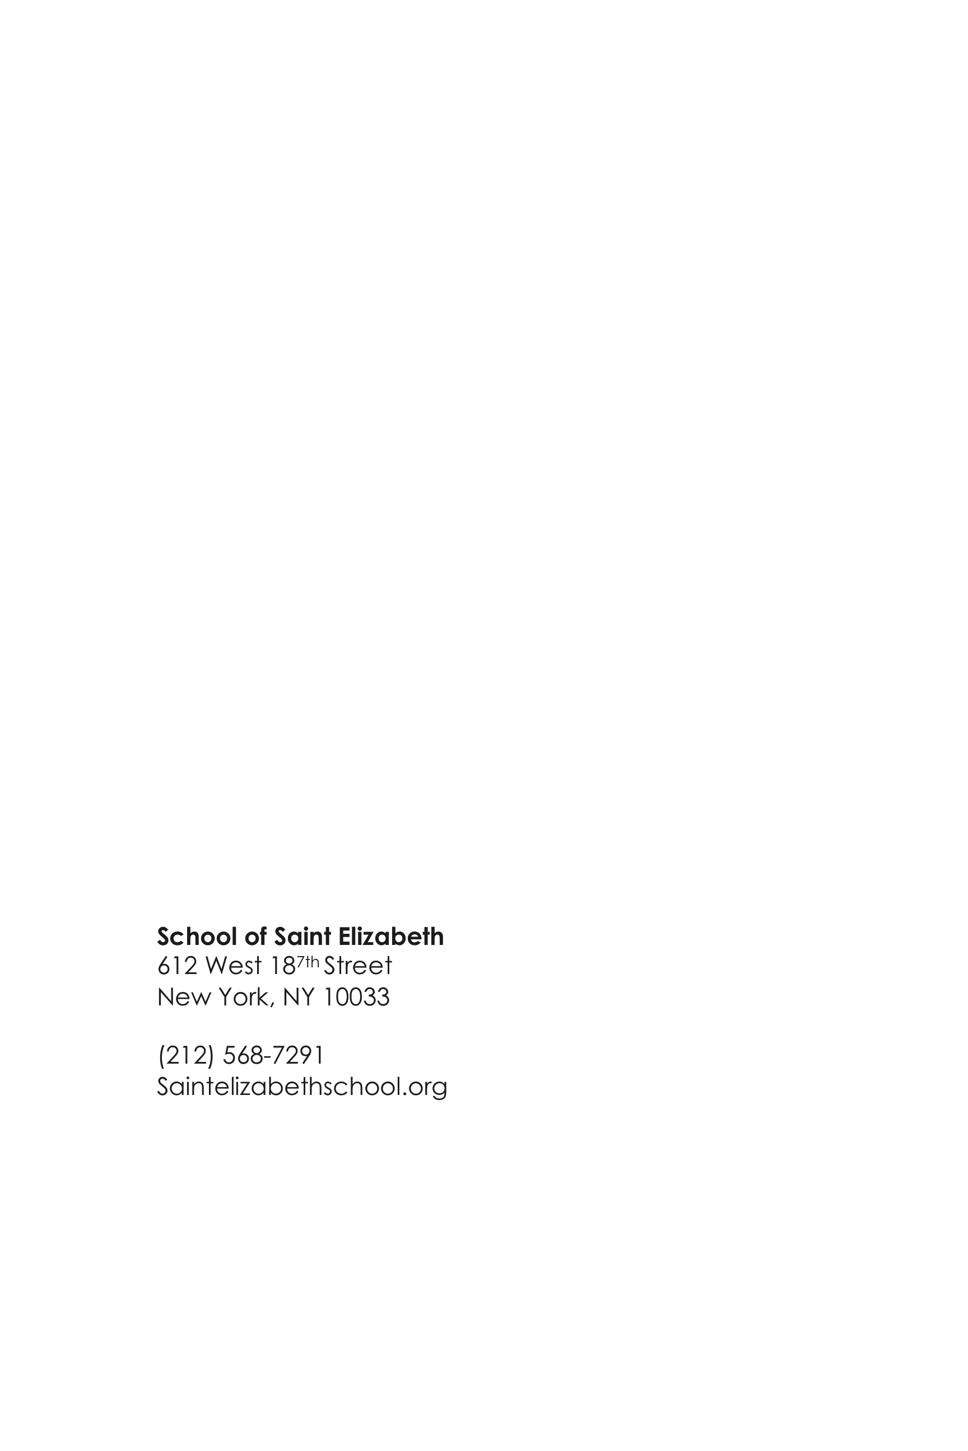 2018
School of Saint Elizabeth
612 West 18^{7th} Street
New York, NY 10033

(212) 568-7291
Saintelizabethschool.org

